MIRAGE
MIDTERM PROJECT
REPORT
Athina Xydi
ITC 4214 – Internet Programming
Leonardos Mageiros
15 November 2025

1. Description of the Task Allocation System
My task allocation system can be found on the Tasks page.
I thought, even if the website is supposed to be a promotional site for a game that has not been released yet, Mirage, the task manager, can be a demo feature for the alpha or beta players, since the game doesn’t have it implemented, yet!
It allows players to:
- Add New Tasks
Players can enter a name, short description, and a due date.
There is also validation that makes sure that:
- All fields are filled
- No past dates are selected
- And there is character limit on both name and description.
- Edit Tasks
All fields (name, description, date) in the table can be edited directly using contenteditable.
Updates are automatically saved to localStorage.
- Mark Tasks as Completed
Each task has a “Complete” button that changes its status and updates the summary and analytics tab.
- Delete Tasks
Tasks can be removed permanently using the delete button.
- Filter & Sort
Users can filter tasks by:
- All
- Pending
- Completed
Sorting can be done by:
- Task Name
- Due Date

- Summary Statistics
A summary is displayed showing:
- Total tasks
- Pending tasks
- Completed tasks
- Local Storage Persistence
All tasks are saved using localStorage, allowing the data to remain even after the browser is refreshed.
- Analytics Dashboard
Located in on the home page, is a pie chart that displays the completed vs the pending tasks.
Nex to it there is also the Latest Activity section powered by the same dataset.

2. Detailed Documentation of Coding
- Tasks Page
Data Storage
Tasks are stored in localStorage under the key "mirageTasks".
This ensures data persistence and allows the Home page to access the same dataset.
let tasks = JSON.parse(localStorage.getItem("mirageTasks")) || [];

Validation
- If there are any empty fields, there’s a popup alert.
- Past dates can’t be selected.
let today = new Date().toISOString().split("T")[0];
if (date < today) { alert("Select a valid future date."); return; }
- maxlength="50" and maxlength="200" were added to HTML inputs
- In JS it ensures that long content won’t break the layout.
Inline Editing
To avoid cluttering the UI with “edit” buttons, inline editing is enabled:
<td contenteditable="true" class="editName">${task.name}</td>
Changes are saved when the user clicks away :
$(document).on("blur", ".editName, .editDesc, .editDate", function () {
tasks[row].name = newName;
saveTasks();
});

Filtering & Sorting
Both features operate on the tasks array in memory and then refresh the table display with showTasks().
Summary Update
Each time tasks change:
updateSummary();

- Latest Activity (Home Page)
The Latest Activity box shows the most recent completed or created task.
- The Home page loads tasks from localStorage
- If tasks exist, the most recent one is displayed
- If not, “No Tasks added yet.” appears

- Page of my choice -- Characters
The Characters page shows some of the main characters of the game Mirage.
Design Decisions
- Character cards styled with Bootstrap
- Custom artwork generated for each character
- Bios written to resemble professional game character profiles
- Layout responsive depending on the screen due to col-lg-4 col-md-6 grid system

3. GitHub Repository
https://github.com/athina-xy/Mirage-Midterm-Project

4. Lighthouse screenshots
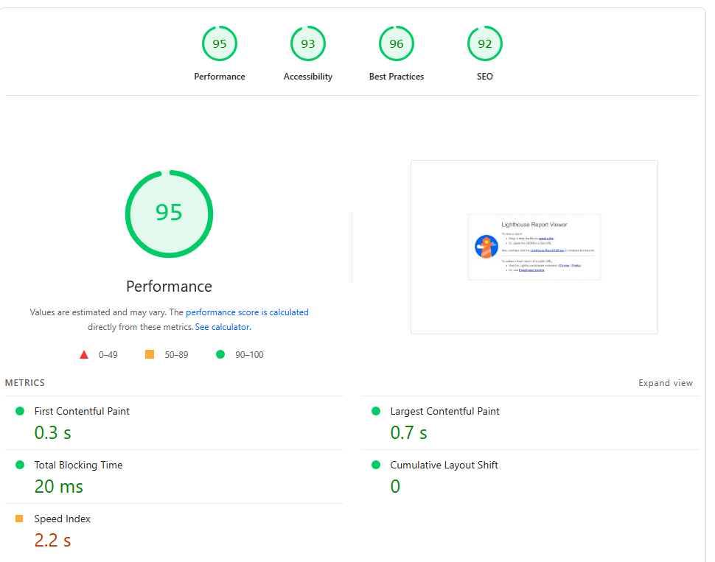
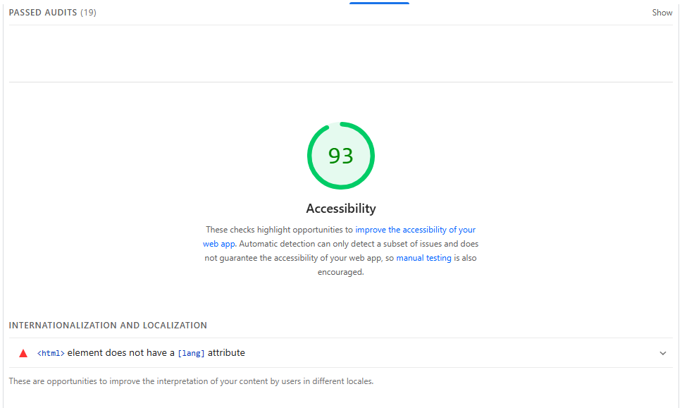
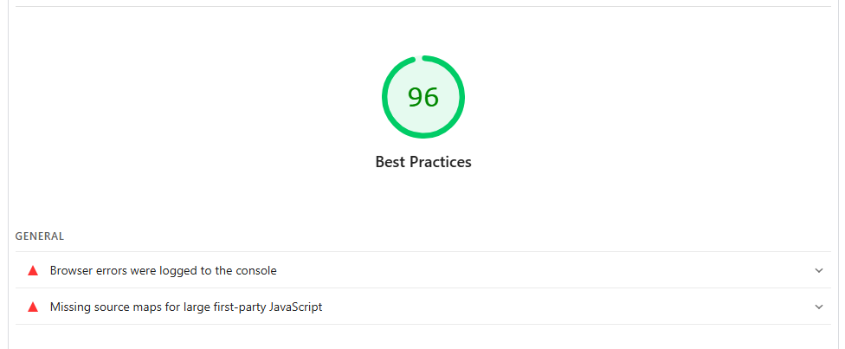
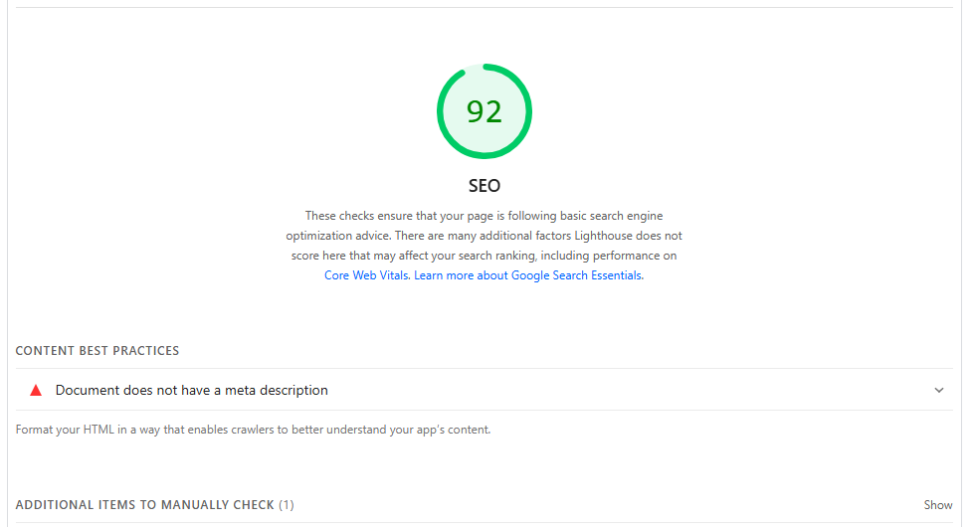

5. Personal Reflection
This project was a big challenge.
Some of the main challenges were loading partials HTML files (navbar/footer) without a backend caused path issues.
I used jQuery’s load() function inside include.js to insert them onto every page.
Another Challenge I had was the Dark/Light theme.
The theme toggle initially broke the specific background. Especially in the Home page were Im using an image.
At the end I ended up separating theme CSS into theme-dark.css and theme-light.css, then I used:
<body data-page="home">
to make sure that the Home page kept its background image no matter what.
Another difficult task was to load the tasks data in the home page.
To deal with that, both pages load from localStorage, and the analytics chart updates automatically based on stored tasks.

Another thing I struggled with was the API link stopped working so the website kept breaking.
It was hard to find an API with quotes that are themed around my game story. I found a random link and replaced it, so now each click retrieves a new message.

